
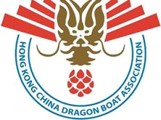
中 國 香 港 龍 舟 總 會

HONG KONG CHINA DRAGON BOAT ASSOCIATION

International Dragon Boat Federation Founding Member 國際龍舟聯合會創會會員 Asia Dragon Boat Federation Founding Member 亞洲龍舟聯會創會會員

Sports Federation & Olympic Committee of Hong Kong, China Affiliated Member 中國香港體育協會暨奧林匹克委員會附屬會員

Ref: HKCDBA/Race/2018/07/003 By Email & Post 30th July 2018

福州大学

彭雪涵(团长)、吴杰忠（副团长兼主教练）、赵炜锌（教练员）
参赛队员：祁张艺琳、杨昕彧、田溪蕊、何斐、程乐旖、朱文婧、张馨儒、陈芷欣、颜杨麒、金怡婕、黄清妙、陈明璐、杨海朋

Dear Team manager,

Centum Charitas Foundation

20th Hong Kong International Dragon Boat Championships 2018

On behalf of the Hong Kong China Dragon Boat Association (HKCDBA), we are writing to cordially invite your team to join the Centum Charitas Foundation 20th Hong Kong International Dragon Boat Championships 2018 which will be held between 26 October to 28 October 2018 at the Kwun Tong Promenade, Kowloon Hong Kong. The races will be held with a series of celebrating events which will definitely bring your team excitement and enjoyment throughout the event.

We would appreciate if you could accept our invitation and the entry fee will be waived. Please kindly reply the following part to the HKCDBA Secretariat through either email or fax on or before 8 August 2018. Should you have enquiries, please feel free to contact Mr. Wong at 3618 7510 or refer to the latest update on www.hkcdba.org.

We look forward to receiving your favourable reply.
Yours sincerely,
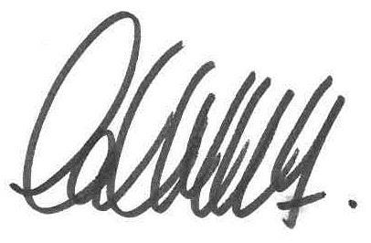

Chung Chi Lok, Arnold
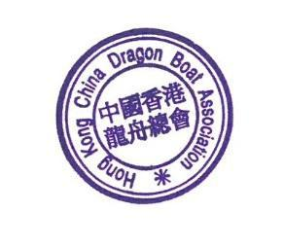

Chairman

Hong Kong China Dragon Boat Association
----------------------------------------------------------------------------------------------------------------------------
 |  |  | REPLY SLIP
 |  | (Please reply on or before 28 March 2018)
To: Hong Kong China Dragon Boat Association
Tel: 3618 7510 | Fax: 2577 1873 |  | Email: hkdba@hkolympic.org

We will join the Centum Charitas Foundation 20th Hong Kong International Dragon Boat Championships 2018

We will not join the Centum Charitas Foundation 20th Hong Kong International Dragon Boat Championships 2018


Organisation 福州大学

Contact Person Contact Number

Unit 21, 28/F New Tech Plaza, 34 Tai Yau Street, San Po Kong, Kowloon, Hong Kong 34 28 21

